**BMB 1203 LABOLATORY PRACTICE & INSTRUMENTATION IN BIOCHEMISTRY**

**BASIC LABORATORY PRINCIPLES AND PROCEDURES**

* **Safety precautions and hazards**

Laboratories can be dangerous places. There are organic solvents which can be health hazards and flammable. It is important to always take precaution while in the laboratory. While in the lab one should take note of the emergency exit and fire alarms as well as where the extinguishers are placed. Faulty technique is one of the chief causes of accidents and, because it involves the human element, is one of the most difficult to cope with.

The purpose of this lecturer is

1. To help the student understand proper laboratory safety
2. To increase the students awareness of the possible risks or hazards involved with laboratory work
3. To realize the laboratory is generally a safe place to work if safety guidelines are properly followed.

**I. STANDARD OPERATING PROCEDURES**

**A. General Personal Safety**

1. Eating, drinking, smoking, applying cosmetics or lip balm, and handling contact lenses are prohibited in areas where specimens are handled.

2. Food and drink are not stored in refrigerators, freezers, cabinets, or on shelves, countertops, or bench tops where blood or other potentially infectious materials are stored or in other areas of possible contamination.

3. Long hair, ties, scarves and earrings should be secured.

4. Keep pens and pencils OUT OF YOUR MOUTH!!

5. Appropriate Personal Protective Equipment (PPE) will be used where indicated:

* **Lab coats** or disposable aprons should be worn in the lab to protect you and your clothing from contamination. Lab coats should not be worn outside the laboratory.
* **Lab footwear** should consist of normal closed shoes to protect all areas of the foot from possible puncture from sharp objects and/or broken glass and from contamination from corrosive reagents and/or infectious materials.
* **Gloves** should be worn for handling blood and body fluid specimens, touching the mucous membranes or non-intact skin of patients, touching items or surfaces soiled with blood or body fluid, and for performing
* venipunctures and other vascular access procedures. Cuts and abrasions should be kept bandaged in addition to wearing gloves when handling biohazardous materials.
* **Protective eyewear** and/or masks may need to be worn when contact with hazardous aerosols, caustic chemicals and when handling fumes is anticipated.

6. **NEVER MOUTH PIPETTE!!** Mechanical pipetting devices must be used for pipetting all liquids.

7. Frequent hand washing is an important safety precaution, which should be practiced after contact with patients and laboratory specimens. Proper hand washing techniques include soap, running water and 10-15 seconds of friction or scrubbing action. Hands should be dried and the paper towel used to turn the faucets off.

**Hands are washed:**

* After completion of work and before leaving the laboratory.
* After removing gloves.
* Before eating, drinking, smoking, applying cosmetics, changing contact lenses or using lavatory facilities.
* Before all other activities which entail hand contact with mucous membranes or breaks in the skin.
* Immediately after accidental skin contact with blood or other potentially infectious materials.
* Between patient contact and before invasive procedures.

8. Laboratory work surfaces must be disinfected daily and after a spill of blood or body fluid with a 1:10 dilution of Clorox in water or using 70% ethanol.

**B. Eye Safety**

1. **KNOW WHERE THE NEAREST EYE WASH STATION IS LOCATED AND HOW TO OPERATE IT.**

2. **Eye goggles should be worn:**

* When working with certain caustic reagents and/or solvents, or concentrated acids and bases.
* When performing procedures that are likely to generate droplets/aerosols of blood or other body fluid.
* When working with reagents under pressure.
* When working in close proximity to ultra-violet radiation (light).
* Wearing contact lenses in the laboratory is discouraged and requires extra precaution if worn. Gases and vapors can be concentrated under the lenses and cause permanent eye damage. Furthermore, in the event of a chemical splash into an eye, it is often nearly impossible to remove the contact lens to irrigate the eye because of involuntary spasm of the eyelid. Persons who must wear contact lenses should inform their supervisor to determine which procedures would require wearing no-vent goggles.

**C. Safe Handling of Biologically Hazardous Material**

1. **YOU SHOULD HANDLE ALL PATIENT SAMPLES AS POTENTIALLY BIOHAZARDOUS MATERIAL.** This meansUNIVERSAL PRECAUTIONS should be followed at all times!!

2. **When working in the laboratory:**

* Wear protective clothing such as lab coat and gloves. If you have a cut/abrasion, also wear a band-aid.
* Avoid spillage and aerosol formation.
* Hands should be washed immediately and thoroughly if contaminated with blood or other body fluids.
* Gloves should be removed before handling a telephone, computer keyboard, etc., and must NOT be worn outside the immediate work area. Hands should always be washed immediately after gloves
* are removed.
* You should wash your hands after completing laboratory activities and before leaving the area. All protective clothing should be removed prior to leaving the lab.
* All biohazardous material should be discarded in a biohazard bag to be autoclaved.
* All counter and table tops should be disinfected with a proper disinfecting solution:
* At the beginning of the day.
* If you should spill a patient sample.
* At the end of the day.

3. **When performing venipuncture:**

* Wear clean gloves for each patient you draw.
* Wash your hands whenever you change gloves.
* Dispose of contaminated needle, syringe and test tubes in a proper biohazardous receptacle.
* When drawing blood from a patient in an isolation room.
* All material taken into this room must remain in the room.
* Label all tubes drawn from this patient with isolation stickers.

4. **Proper handling of SHARPS:**

* Contaminated needles and other sharps are never broken, bent, recapped or re-sheathed by hand.
* Used needles are not removed from disposable syringes.
* Needles and sharps are disposed of in impervious containers located near the point of use.

**II. CHEMICAL AND GAS SAFETY**

To provide a safe working environment, all personnel should be aware of potentially hazardous materials and the proper way of handling this material. Avoid unnecessary exposure to chemicals. Occupational Safety and Health Administration (OSHA) requires any necessary information in the form of MATERIAL SAFETY DATA SHEETS (MSDS) concerning the handling of hazardous materials to be available to all

laboratory personnel, so that they may achieve and maintain safe working conditions. Chemical routes of entry include;

* Via the respiratory tract due to inhalation
* Skin absorption from liquid, solid and gaseous form of chemical in contact with bare skin
* Gastro-intestinal tract due to accidental ingestion

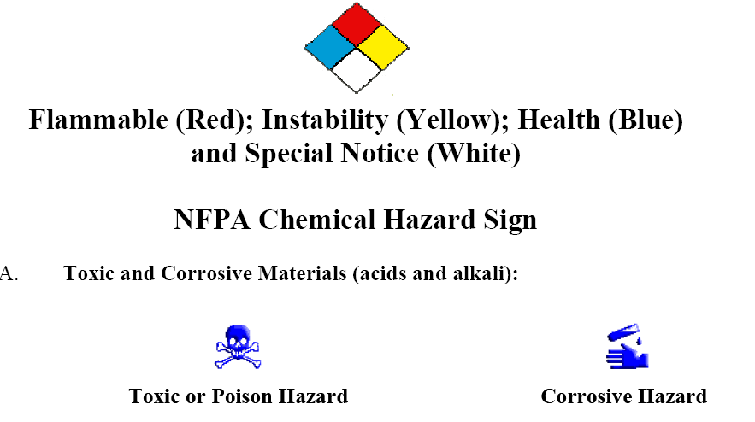

**Toxic or Poison Hazard Corrosive Hazard**

1. To avoid dangerous splatter, **ALWAYS ADD ACID TO WATER! NOT WATER TO ACID**

2. Toxic materials should be labeled with special tape when used in compounded reagents and stored in separate containers. These materials should be handled carefully and kept in the hood during preparation.

3. Acids and alkali should be carried by means of special protective carriers when transported.

4. Acid and alkali spills should be covered and neutralized by using the material from the ‘spill bucket’. All material, spill and compound, should be swept up and placed in a plastic bucket for proper disposal.

5. In case of spillage, wash all exposed human tissue (including eyes) generously with water and notify your supervisor for proper reporting of the incident.

B**. Carcinogens and Mutagens**

1. All laboratory chemicals identified as carcinogens must be labeled **CARCINOGEN**.

2. When working with these substances, protective clothing and gloves should be worn.

 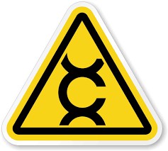 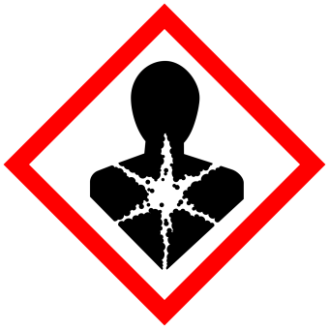

1. Mutagens are physical or chemical agents that cause the genetic information in an organism to change increasing the frequency of mutations above the natural background level. They do cause cancer and are known as carcinogens and in some cases are utilized in molecular biology experiments.

C**. Flammable Compounds**

1. All flammable reagents should be kept in the flammable storage facilities (closet or refrigerator) at all times when not in use.

2. Any solutions compounded from these reagents should be labeled as flammable.

3. Flammable substances should be handled in areas free of ignition sources.

4. Flammable substances should never be heated using an open flame.

5. Ventilation is one of the most effective ways to prevent accumulation of explosive levels of flammable vapors. An exhaust/ fume hood should be used whenever appreciable quantities of flammables are handled.

6. Flammable compounds should be placed in proper receptacle for disposal.

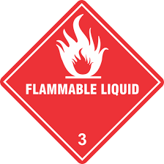 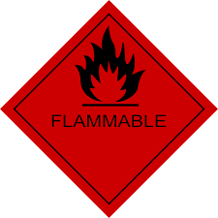 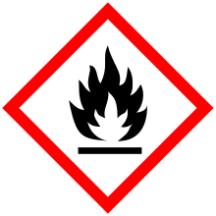

Organic compounds are highly flammable and have low melting point as seen in the table below

|  |  |  |  |  |
| --- | --- | --- | --- | --- |
| **Common solvent** | **Boiling point (760mm) °C** | **Flammability** | **Toxicity** | **Specific g** |
| Acetic acid | 78 | Low | Low | 1.05 |
| Acetone | 57 | Very high | Low | 0.79 |
| Benzene | 80 | Very high | Very high | 0.88 |
| Carbon tetrachloride | 77 | Not | High | 1.59 |
| Chloroform | 61 | Not | High | 1.48 |
| Dichloromethane | 40 | Not | Medium | 1.33 |
| Ethanol | 79 | High | Low | 0.79 |
| Ether | 35 | Very high | Medium | 0.71 |
| Ethyl acetate | 77 | High | Medium | 0.90 |
| Light petroleum | 40.6 | Very high | Low | 0.65 |
| Methylated spirit | -79 | Very high | Medium | -0.79 |
| Methanol | 65 | High | Very high | 0.79 |
| Petroleum spirit | 60.8 | Very high | Low | 0.67 |
| Pyridine | 75 | Medium | Very high | 0.98 |

D. **Ether Precautions (flammable compound)**

1. These compounds tend to react with oxygen to form explosive peroxides. When ether containers are opened they are to be dated and all material remaining after six (6) months must be disposed of immediately.
2. Disposal of ether compounds is through the Hazardous Materials Office.
3. Ether compounds will be stored in an explosion-proof refrigerator. (boiling point of ether is approximately room temperature)

E. **Compressed Gases**

1. The storage of all compressed gases shall be in containers designed, constructed, tested and maintained in accordance with specific regulations
2. In the laboratory, gas containers are to be limited to the number of containers in use at any time. Low pressure (LP) gases shall also be limited to the smallest size container.
3. Containers shall be securely strapped, chained or secured in a cylinder stand so they cannot fall.
4. Oxidizing gases should be separated from flammable gasses.

F. **Chemical hazard symbols**

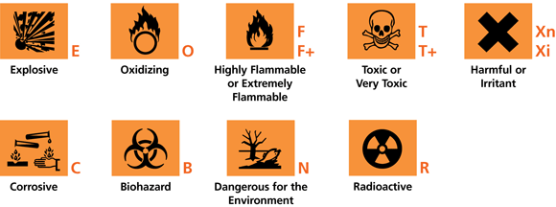

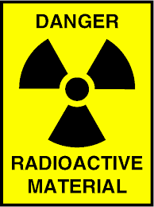 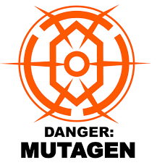 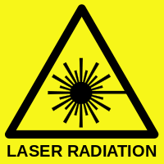 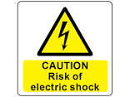

G. **Biohazard**

* These include substances that can harm humans and animals as well.
* Microorganisms are classified depending on the diseases they cause to humans. This microorganism are classified in order to design safe cabinet in to handle the microorganism in study and known disease they cause
* Biohazard Level 1 organism;
* If working with Bacillus subtilis, E. coli, Chicken pox as well as some cell cultures and non-infectious bacteria, this can be dealt with on open bench
* Biohazard Level 2 organism;
* Hepatitis B, Hepatitis C, Influenza, Lyme disease, Salmonella, HIV
* Biohazard Level 3 organism;
* Anthrax, Mumps, West Nile virus, SARS, Small pox, TB, Typhoid fever, Yellow fever
* Biohazard Level 4 organism;
* Dengue fever, Marburg virus, Ebola, Hantaan virus, Lassa virus and other hemorrhagic diseases

**III. RADIATION SAFETY**

1. No eating, drinking, smoking permitted!
2. Radioactive material should be labeled as radioactive and stored in a proper container so as to prevent spillage or leakage.
3. These materials must be handled carefully. Remember: **the amount of radiation exposure decreases with distance.**
4. Radioactive spills should be absorbed with absorbent toweling. The area should be cleaned with soap and water and then decontaminated with a product such as ‘count-off’. The area of the spill is then monitored for any residual radioactivity. If the area is not decontaminated, the above regimen is repeated and re-monitored.
5. In the case of a radioactive spill in a high used area, the area will be ‘roped off’ until proper decontamination has been achieved.
6. In the case of a major radioactive spill, all personnel in the area must be notified. The appropriate safety officer must be notified and all attempts to keep contamination at a minimum must be used.

**IV. FIRE SAFETY**

* **KNOW WHERE ALL FIRE EXITS, FIRE EXTINGUISHERS AND FIRE ALARMS ARE LOCATED!**
* **KNOW HOW TO PROPERLY OPERATE APPROPRIATE FIRE ALARMS AND FIRE SAFETY EQUIPMENT!** Portable fire extinguishers are classified by their ability to handle specific classes of fires:
* For burning combustible materials (wood, paper, clothing, trash). **GREEN TRIANGLE WITH**
* **THE LETTER ‘A’**, uses water or an all-purpose dry chemical.
* For burning liquids: **RED SQUARE WITH THE LETTER ‘B’,** uses foam, a dry chemical or carbon dioxide.
* For electrical fires: **BLUE CIRCLE WITH THE LETTER ‘C’** uses non-conducting extinguishing
* agents (carbon dioxide or a dry chemical).
* Multipurpose: Recommended for all types of fire. Most common extinguisher found in most clinical laboratories.
* C. Know the proper procedure for notifying colleagues and proper personnel of a fire.

**R A C E**

* **R**escue those in danger
* **A**larm
  + Activate the fire pull station
  + Notify switchboard operator of the location, your name and the type of fire, if known
* **C**ontain the fire by closing all doors and windows
* **E**xtinguish the fire, if possible. Do not re-enter a room that has already been closed.

**E**vacuate

**V. ELECTRICAL SAFETY**

1. Never operate electrical equipment with fluid spillage or with wet hands.
2. Never use plugs with exposed or frayed wires.
3. If there are sparks or smoke or any unusual evens occur, shut down the instrument and notify the manager or safety officer. Electrical equipment that is not working properly should not be used.
4. If a person is shocked by electricity, shut off the current or break contact with the live wire immediately. Do not touch the victim while he is in contact with the source of current unless you are completely insulated against shock. Victims should be taken to the student health center.

**VII. GENERAL PROCEDURES AND EQUIPMENT**

1. Cracked or chipped glassware should not be used.
2. Centrifuges should not be used without the covers completely closed.
3. When removing tops from evacuated test tubes, care must be taken to prevent aerosol formation.

**VIII. IN CASE OF ACCIDENTS**

1. Accidental Needle Stick

* Bleed wound.
* Wash wound thoroughly with soap.
* Notify the supervisor of the incident and report to Student Health with an incident report form.
* May need to get blood tested for hepatitis.

1. If you should wound yourself in the laboratory:

* Any type of accident should be brought to the attention of the Teaching Supervisor of the area.

**IX. SUMMARY……….USE COMMON SENSE!!!**

**GLASSWARE**

* **Types of laboratory glass and plastic ware**
* **Introduction**
* Laboratory glassware and plastic wares are widely used in the medical laboratories. Glassware are manufactured from boro-silicate glass.
* Boro-silicate glass is a material with the following defined characteristics;
* Resistant to the action of chemical with the exception of hydrofluoric and phosphoric acid
* Made to withstand mechanical breakage
* Made to withstand sudden change of temperature
* Glassware produced from soda lime type of glass does not fit the above requirements and is easily broken by mechanical stress produced by a sudden change of temperature.
* Hardened glasses, such as pyrex, monax and firmasil have low soda lime content and are manufactured especially to resist thermal shock (high temperature).
* The walls of these vessels are generally thicker than those made from soda lime. The high proportion of boro-silicate increases the chemical durability of the glassware.
* It is important to note that all glassware must be handled with care. Breakage can sometimes be dangerous and may result in the loss of valuable and irreplaceable materials.
* Flasks and beakers should be placed on a gauze mat when they are heated over a Bunsen burner flame. The gauze mat is made from asbestos that functions to distribute heat evenly
* Test tubes that are exposed to a naked flame should be made of heat resistant glass. If liquids are to be heated in a bath or boiling water, the glass contents should be heat resistant. Sudden cooling of hot glass should be avoided as the glass can break due to thermal shock
* When diluting concentrated acids, thin walled glassware should be used since the heat evolved by the procedure often cracks thick glassware eg., hydrochloric and sulfuric acid.
* Heat expansion is liable to crack bottles if their caps are screwed on too tightly so if heat is applied, flasks should not be tightly clamped.
* Containers and their corresponding ground glass stoppers should be numbered in order to ensure direct matching when stoppers are placed.
* Due to danger of chemical and bacterial contamination it is important that pipettes should never be left on the bench.
* **Volumetric Wares**
* Volumetric wares are apparatus used for the measurement of liquid volume. They can be made from either glass or plastic ware and include pipettes, volumetric flasks, graduated measuring cylinders and burettes
* ***Pipettes***
* There are several types each having its own advantages and limitations. Pipettes are used in scientific labs. Their specific purpose is to suck up a liquid of the lab user's choosing, then contain the liquid so it can be transferred into another container. Some pipettes are not very precise and are meant more for transferring than measuring liquid, while others are very precise and measure the volume of liquid.
* There are three types of pipettes; volumetric pipettes and measuring pipettes.
* **Volumetric pipettes** are used to transfer a specific volume of a given liquid. It usually has a capacity of between 1 and 100 mL. They can be shaped somewhat like a rolling pin, with two thinner ends and a thicker bulge in the middle. These are used when precision in measuring the transferred liquid is important for recording.

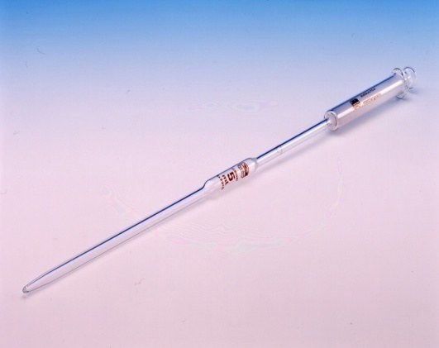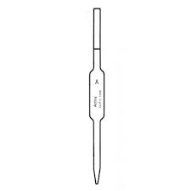

* Volumetric pipettes are calibrated to deliver a constant volume of liquid
* The most commonly used sizes are 1, 5 and 10 ml capacities. Less frequently us sizes are those which deliver 6, 8 an 12 ml.
* The purpose of the bulb between the mouthpiece and the tip is to decrease the surface area per unit volume and to diminish the possible error resulting from water film.
* The volume (capacity) and calibration temperature of the pipette are clearly written on the bulb. They should be put into perspective when a high degree of accuracy is required.
* When using this pipette or any other it is important to rinse it first with the solution to be pipette. The liquid is allowed to fall to the mark and the tip is carefully wiped with a filter paper. The contents are allowed to drain to the appropriate vessel. A certain amount of liquid will remain at the tip and this must not be blown out.
* **Measuring or graduated pipettes** are straight tubes with one tapering end. They have clearly marked hash marks along the side of the tube, so multiple amounts of liquid can be measured with a single pipette. These kinds of pipettes can usually measure a volume between 0.1 mL and 25 mL. While they can measure multiple amounts of liquid at once, imperfections in their tube's internal diameter means they are not as precise in their measurements as volumetric pipettes.
* Measuring pipettes are common only in 0.1, 0.2, 0.5, 1.0, 5.0 and 10 ml sizes. Liquid is usually delivered by allowing it to fall from one calibration mark to another.

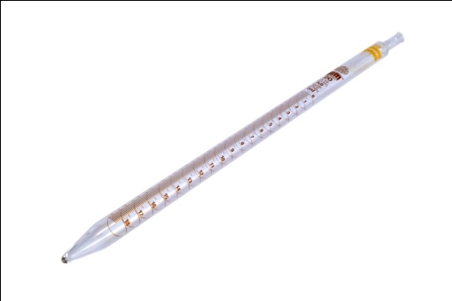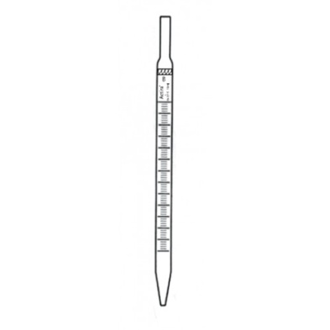

* Measuring pipettes are further subtyped into Mohr pipettes and serological pipettes
* **Serological pipettes** have graduations that continue down into the tips. Some serological pipettes are also blow-out pipettes. These pipettes have an open top, much like a straw, where the user holds his thumb over the top to create the vacuum and seal the liquid in the pipette. Blow-out pipettes allow you to blow into this open end to get the last bits of liquid left in the pipette into your receiving container, for greater accuracy. Blow-out pipettes are clearly marked with a frosted band or two thin rings around the neck. Do not mistake a color coding from a manufacturer for the markings of a blow-out pipette. While you can use blow out pipettes in their intended manner, it is dangerous to do this with a pipette that is not clearly marked as being a blow-out.
* **Mohrs pipettes** has hash marks, or graduations, the graduations always end before the pipette's tip.

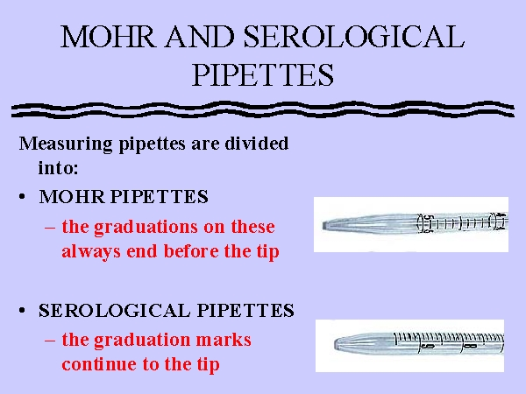

* Pipettes are also classified according to their accuracy into measuring liquids into class A and B.
* Class A pipettes are the most accurate and the tolerance limits are well defined that is +0.01, +0.02 and +0.04 ml for 2, 25 and 50 ml pipettes respectively.
* Class B pipettes are less accurate but quite satisfactory for most general laboratory purposes.
* Significant errors usually result if the temperature of the liquid pipetted is widely different from the temperature of calibration. The usual temperature of calibration is 20 °C and this is marked on the pipette
* ***Micropipette and Micropipette tips***
* Micropipettes are frequently used in medical chemistry, virology, immunology and serology. [Micropipettes](http://www.pipette.com/singlechannel/micropipipette) are utilized in the laboratory to transfer small quantities of liquid, usually down to 0.1 uL. Micropipettes use a [disposable pipette tip](http://www.pipette.com/pipette-tips) to aspirate liquid, note that the tip is the only part of the pipette that makes contact with the solution. A new tip is utilized for every sample in order to prevent cross contamination.

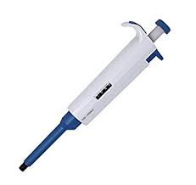 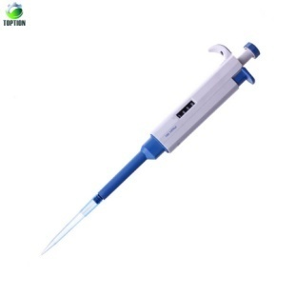 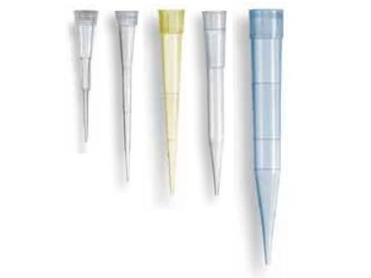

* ***Graduated cylinders:***
* They are useful for measuring liquid volumes to within about 1%. They are for general purpose use, but not for quantitative analysis. If greater accuracy is needed, use a pipette or volumetric flask.

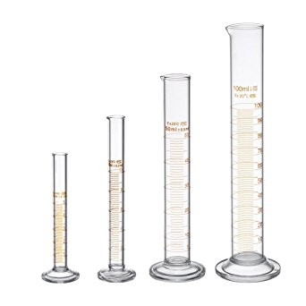

* ***Burettes:***
* It is used to deliver solution in precisely-measured, variable volumes. Burettes are used primarily for titration, to deliver one reactant until the precise end point of the reaction is reached.

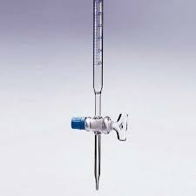

* ***Volumetric flasks:***
* It is used to make up a solution of fixed volume very accurately.
* To make up a solution in volumetric flask, first dissolve the solid material completely, in less water (or solvent) than required to fill the flask to the mark. After the solid is completely dissolved, very carefully fill the flask to the mark. Move your eye to the level of the mark on the neck of the flask and line it up so that the circle around the neck looks like a line, not an ellipse. Then add distilled water a drop at a time until the bottom of the meniscus lines up exactly with the mark on the neck of the flask. Take care that no drops of liquid are in the neck of the flask above the mark. Finally, cover the flask by its cover and remember to mix your solution thoroughly, by inverting the flask and shaking.

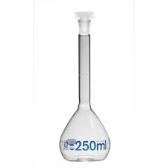

* ***Beakers***
* Used for measuring liquid roughly volume with low accuracy.

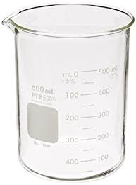

* ***Elenmeyer flask***
* Used for titration or filtration of liquids and to prevent air contamination to sample during work

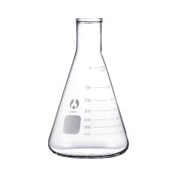

* ***Crucible***
* Used for burning samples at high temperature such as in the furnace

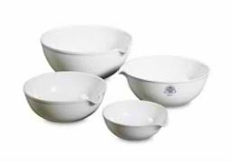

* ***Mortar and Pestle***
* Used for graining materials which have large particle size to small

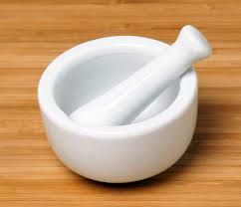

* ***Round bottom flask***
* Used for distillation or heating of  liquid, allows uniform heating

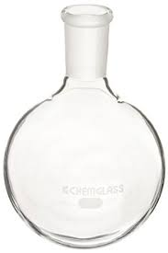

* ***Separating funnel***
* Used for Liquid-Liquid extracts, designed for increase separation efficiency

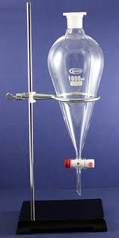

* ***Watch glass***
* Used  for air drying or oven drying of liquid



* ***Funnel***
* Used for liquid transfer. Also for simple filtration

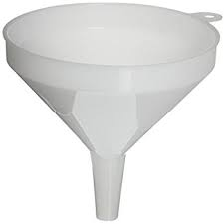 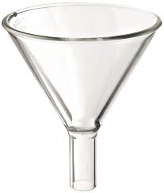

* ***Wash bottle***
* Used for dispensing small amount of liquid like solvent of distilled water

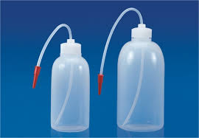

* ***Glass rod***
* Used for stirring of liquid for several purposes

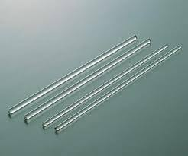

* ***Dessicator***
* Used for storage of material and protect it from air contamination or humidity

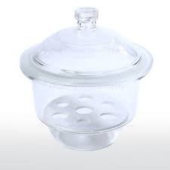

* ***Droppers***
* Used for transfer liquid drop by drop

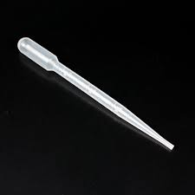 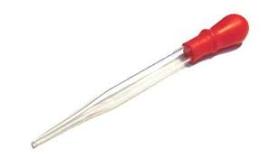

* ***Condenser***
* Used for condensing volatile liquids during distillation

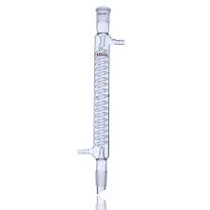

**Laboratory equipment**

* ***Thermometer***
* Used for measuring temperature

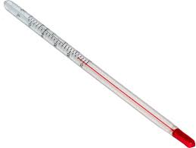 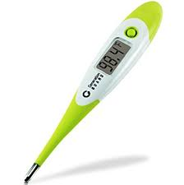

* ***Burette clamp***
* Used along with stand to hold burette

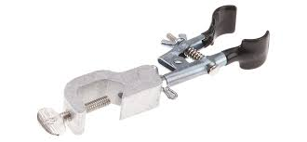

* ***Bottle top dispenser***
* Used for transfer accurate amount from the bottle (mostly used for acids and organic solvent)

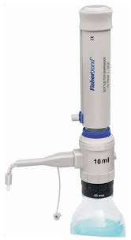

* ***Centrifuge***
* Used for separation of precipitations from supernatant

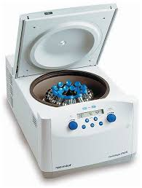

* ***Weighing balance***
* Used for measuring mass of materials

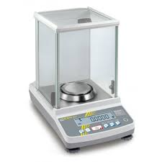

* ***Heat mantle***
* Used as a source of heat mainly for distillation system

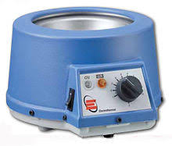

* ***Bunsen burner***
* Used and heat source

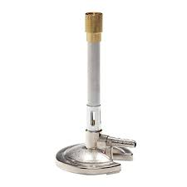

* ***Wire gauze***
* Used for spread the head of burner homogeneously

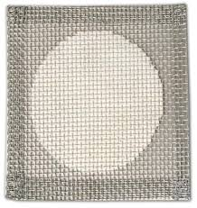

* ***Pipette bulb***
* Used along with pipette to suck liquid

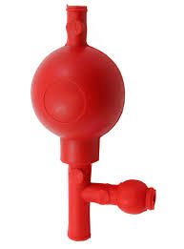

* ***Stand***
* Used commonly as base for holding distillation system and burette along with clamp and boss head

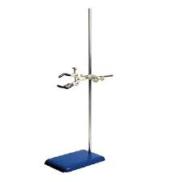

* ***Spectrophotometer***
* It measures either the amount of light reflected from a sample object or the amount of light that is absorbed by the sample object. They measure light intensity as a function of wavelength and are commonly used to measure the concentration of a compound in an aqueous solution

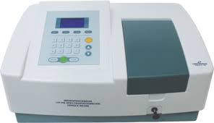

**Errors of measurement**

In any scientific experiment it is necessary to know how good the results are. We evaluate our results by determining their error. The word error does not necessarily imply that one has been careless. Even with the best technique, measured values are never perfectly well known, but contain some uncertainty. Errors in experimental measurements may be divided into two classes: (a) systematic errors and (b) random errors.

*Systematic errors.* Systematic errors are quite reproducible and arise from failure or incompleteness of underlying theory, a shortcoming in the instrumentation or procedure, or failure to account for an experimental variable. We characterize the magnitude of systematic errors by specification of the *accuracy*. This term is defined as the difference between the observed value and the true value of the quantity. Thus accuracy is a measure of the correctness of the result. An accurate measurement is one in which the systematic errors have been eliminated in so far as possible.

The ultimate goal of any analysis is to have the measured value be the same as the true value. Of course, one of the fundamental difficulties in real scientific investigations is that the true value is not known. However, in the student laboratory, the true value has been established through use of independent reference methods as performed by well-trained personnel.

In the world of science, a central preoccupation is to arrive at the "true" answer by reduction of systematic error. Often this involves repeating the experiment many times, systematically changing as many variables as possible: trying a different location, a different source for the starting materials, a different instrument, etc. In practice, such experimental manipulations are difficult to carry out, but for crucial experiments, such as testing a fundamental theory of nature, they are always done. More common, one simply analyzes the experiment carefully, checking each step to see what 'hidden' influences might be present. This requires the scientist to think through the entire experiment to find all the flaws in it. For example, if temperature variations seem to be a problem, a little heat can be applied to see if any results change.

Random errors are deviations (irreproducibilities) in observation which yield results which differ from experimental to experiment. These irreproducibilities are characterized by their precision. The precision of a series of measurements thus reflects how closely each measurement in a series agrees with the others.

**Accuracy and precision**

Accuracy refers to the closeness of a measured value to a standard or known value. For example, if in lab you obtain a weight measurement of 3.2 kg for a given substance, but the actual or known weight is 10 kg, then your measurement is not accurate. In this case, your measurement is not close to the known value.

Precision refers to the closeness of two or more measurements to each other. Using the example above, if you weigh a given substance five times, and get 3.2 kg each time, then your measurement is very precise. Precision is independent of accuracy. You can be very precise but inaccurate, as described above. You can also be accurate but imprecise.

For example, if on average, your measurements for a given substance are close to the known value, but the measurements are far from each other, then you have accuracy without precision.

A good analogy for understanding accuracy and precision is to imagine a basketball player shooting baskets. If the player shoots with accuracy, his aim will always take the ball close to or into the basket. If the player shoots with precision, his aim will always take the ball to the same location which may or may not be close to the basket. A good player will be both accurate and precise by shooting the ball the same way each time and each time making it in the basket.

**SOLUTIONS AND CONCENTRATION**

A **solution** is a homogenous mixture of one substance (A solute) dissolved in another substance (a solvent). A solution consists of a solute and a solvent. The solute is the substance that is dissolved in the solvent. The amount of solute that can be dissolved in solvent is called its [solubility](https://www.thoughtco.com/definition-of-solubility-604649). For example, in a saline solution, salt is the solute dissolved in water as the solvent. A solution may exist in any [phase](https://www.thoughtco.com/definition-of-phase-in-chemistry-604603). For solutions with components in the same phase, the substances present in lower concentration are solutes, while the substance present in highest abundance is the solvent.

**Characteristics of a solution**

A chemical solution exhibits several properties:

* A solution consists of a homogeneous mixture.
* A solution is composed of one phase (e.g., solid, liquid, gas).
* Particles in a solution are not visible to the naked eye.
* A solution does not scatter a light beam.
* Components of a solution cannot be separated using simple mechanical filtration.

### Solution Examples

* Any two substances which can be evenly mixed may form a solution. Even though materials of different phases may combine to form a solution, the end result always exists of a single phase.
* An example of a [solid](https://www.thoughtco.com/definition-of-solid-604648) solution is brass. An example of a [liquid](https://www.thoughtco.com/definition-of-liquid-604558)solution is [aqueous](https://www.thoughtco.com/definition-of-aqueous-solution-604370) hydrochloric acid (HCl in water). An example of a [gaseous](https://www.thoughtco.com/definition-of-gas-604478) solution is air.

| **Solution Type** | **Example** |
| --- | --- |
| gas-gas | air |
| gas-liquid | carbon dioxide in soda |
| gas-solid | hydrogen gas in palladium metal |
| liquid-liquid | gasoline |
| solid-liquid | sugar in water |
| liquid-solid | mercury dental amalgam |
| solid-solid | sterling silver |
|  |  |

The relationship between solution, solvent and solute can be expressed through various concentration units. **Concentration** is a ratio of the amount of solute to the amount of solvent. Some common measurement units of concentration include molarity, molality, and normality.

***Molarity***: Molarity is the most common concentration unit. It is a measure of the number of moles of solute in one liter of solution. Molarity measurements are denoted by the capital letter M with units of moles/Liter.

Formula for Molarity is

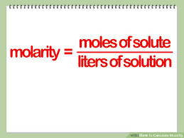 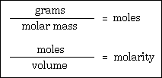

***Normality:***  It is a measure of concentration equal to the gram equivalent weight per liter of solution. Gram equivalent weight is the measure of the reactive capacity of a molecule. The solute's role in the reaction determines the solution's normality**.** Normality is a concentration unit seen more often in acid-base and electrochemistry solutions. It is denoted by the capital letter N with units of moles/L. Normality is more concerned with the chemically active part of the solution. For example, take two acid solutions, hydrochloric (HCl) acid and sulfuric (H2SO4) acid. A 1 M solution of HCl contains one mole of H+ ions and one mole of Cl– ions where a 1 M solution of H2SO4 contains 2 moles of H+ ions and one mole of SO4– ions. The sulfuric acid produces twice the number of active H+ ions as the same concentration of HCl. Normality addresses this with the idea of chemical equivalent units. Equivalent units are the ratio of the number of moles of solute to the number of moles needed to produce 1 mole of the active ion. In our example, this ratio is 1:1 for HCl, both H+ and Cl– ions so the equivalent unit for both ions is 1. For H2SO4, the ratio is 1:1⁄2 for H+ and 1:1 for SO4–. The equivalent unit for H+ is 2 and 1 for SO4–.

This formula is used to calculate the normality of a solution

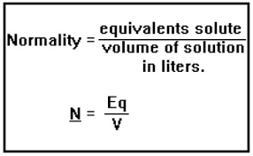

Note it is essentially the same as the molarity equation with the addition of equivalent units.  
For our example, the 1 M solution of HCl would have a normality of 1 N for both H+and Cl– and the 1 M H2SO4 would have a normality of 2 N for H+ and 1 N for SO4–.

***Molality***: Molality is another commonly used concentration unit. Unlike molarity, molality is interested in the solvent used to make the solution. Molality is a measure of the number of moles of solute dissolved per kilogram of solvent. This unit is denoted by the lower case letter m. Molality is used when temperature is part of the reaction. The volume of a solution can change when temperature changes. These changes can be ignored if the concentration is based on mass of the solvent.

Formula for calculation of Molality is

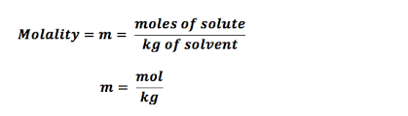

**ANALYTICAL PROCEDURES AND INSTRUMENTATION**

**Volumetric (Titrimetric) Analysis**

*General Principles*In titrimetric analysis volumetrically measures the amount of reagent, often called a titrant, required to complete a chemical reaction with the analyte. A generic chemical reaction for titrimetric analysis is

http://ion.chem.usu.edu/~sbialkow/Classes/3600/Overheads/Titration/Image1.gif

where *a* moles of analyte *A* contained in the sample reacts with *t* moles of the titrant *T* in the titrant solution.

The reaction is generally carried out in a flask containing the liquid or dissolved sample. Titrant solution is volumetrically delivered to the reaction flask using a burette. Delivery of the titrant is called a titration. The titration is complete when sufficient titrant has been added to react with all the analyte. This is called the *equivalence point*

An indicator is often added to the reaction flask to signal when all of the analyte has reacted. The titrant volume where the signal is generated is called the *end point*. The equivalence and end points are rarely the same.

*Successful Titrimetric Analysis*

A few rules of thumb for designing a successful titration are:

* The titrant should either be a standard or should be standardized.
* The reaction should proceed to a stable and well defined equivalence point.
* The equivalence point must be able to be detected.
* The titrant’s and sample’s volume or mass must be accurately known.
* The reaction must proceed by a definite chemistry. There should be complicating side reactions.
* The reaction should be nearly complete at the equivalence point. In other words, chemical equilibrium favors products.
* The reaction rate should be fast enough to be practical.

**Gravimetric analysis**

Gravimetric analysis is a general term used to describe tests in which the final result is determined by weighing. Gravimetry includes all analytical methods in which the analytical signal is a measurement of mass or a change in mass. When you step on a scale after exercising you are making, in a sense, a gravimetric determination of your mass. Another example is when solids are suspended in water they can be filtered and their mass weighed.

*Gravimetric Analysis can be done through*

1. **Volitilization** in this the analyte or its decomposition products are volatilized at a suitable temperature. The volatile product is then collected and weighed, or, alternatively, the mass of the product is determined indirectly from the loss in mass of the sample.
2. **Precipitation** in this method the analyte is converted to a sparingly soluble precipitate. This precipitate is then filtered, washed free of impurities, and converted to a product of known composition by suitable heat treatment, and the product is weighed.

A gravimetric precipitating agent should react specifically, and selectively with the analyte. The ideal precipitating reagent would react with the analyte to give a product that is

1. Readily filtered and washed free of contaminants
2. Of sufficiently low solubility so that no significant loss of the solid occurs during filtration and washing
3. Unreactive with constituents of the atmosphere
4. Of known composition after it is dried or, if necessary, ignited

Precipitates made up of large particles are generally desirable in gravimetric work because large particles are easy to filter and wash free of impurities. In addition, such precipitates are usually purer than are precipitates made up of fine particles.

1. Electro analytical methods
2. Miscellaneous physical methods

**Colorimetric analysis**

Colorimetric analysis literally means 'measure the colour'. Many chemicals will impart a colour to water or will react with a chemical reagent resulting in the formation of a coloured product.

Measuring colour can be:

* **subjective**, compare the colour to a colour chart
* **objective**, use a meter to measure the amount of light absorbed by the sample.

### For example

### Chlorine Residual

Chlorine is not present naturally in water. It is added at the water treatment plant as chlorine gas. The chlorine gas reacts with water to form a mixture of hypochlorous acid (HOCl) and hypochlorite ions (OCl-). These are powerful oxidizing agents and will kill bacteria and most viruses in the water. Guidelines set down a minimum level of residual chlorine in treated water to make it safe to drink.

Residual chlorine can be estimated using a chemical abbreviated to N,N-Diethyl-p-phenylenediamine **(**DPD) sulfate. This chemical will turn red in the presence of chlorine. The 'redness' of the solution may be determined by comparison with a colour chart or using a meter known as a colorimeter. Using a colorimeter is a more accurate reading

1. **pH**

There are a range of colorimetric indicators to measure pH such as

* Phenolphthalein will be magenta (Reddish purple) at pH>8.2 and colourless below this level.
* Methyl Orange will be red at pH > 4.3 and orange below this level.
* Litmus is a chemical derived from the plant, lichen, which will be blue at pH>7 (basic) and red at pH below 7 (acidic).

**Potentiometric analysis**

These tests use 'ion specific' electrodes that measure potential difference (voltage) in direct proportion to the concentration of the ion in solution.

**For eaxample**

**pH**

pH is commonly measured using an electrode specific for H+ ions. The electrode is incorporated into a meter or pen. Done using a pH meter

**Fluoride**

An electrode used to measure Fluoride ion (F-), has a small crystal of Lanthanum Fluoride (LaF3) at the end of an electrode. Done using fluoride meter

**NH4+(L3)**

An electrode specific to ammonia is used. A solution of concentrated caustic soda and EDTA is added prior to measurement to convert the ions to ammonia and 'tie up' metal ions which may affect the result.

Electrodes are very sensitive and must be handled and stored very carefully. Background factors will affect the voltage produced and electrodes will need to be calibrated using known solutions prior to each use.

The calibration may be a 1-point calibration with a standard close to the expected value or a 2-point calibration (preferred) using solutions either side of the expected range.

**Spectrophotometric analysis**

These tests are an extension of colorimetric tests. They use a specific wavelength of light that is absorbed only by the target chemical. The amount of light absorbed is proportional to the concentration of the chemical. Majorly based on beer lamberts law

Common tests performed in the laboratory are colour and UV absorbance. As with other electronic meters, calibration using standard solutions is required on a regular basis. The spectrophotometer records the absorbance in Absorbance units

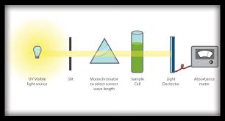

**Examples**

Water containing tannins (the same chemicals responsible for the colour of a cup of tea) will show a brown tinge. Tannins in water are not harmful, but are considered undesirable. Recording the amount of light with a wavelength of 456 nm will give a measure of the amount of tannin in the water.

**Metals ions and heavy metals**

Spectrophotometric analysis can be used on metal ions such as Fe3+ , Al3+, Mn2+ and heavy metals such as Hg2+, Pb2+ and Cd2+.

Levels of metals ions in water as a result of natural leaching from the soil (eg Fe3+) or as a result of processes undertaken in the water treatment plant (eg Al3+) are strictly monitored and controlled in potable (suitable for drinking) water.

When energized, metal ions emit light which is a unique combination of wavelengths. A spectrophotometric analysis test ecxample is to pass light of a unique wavelength (eg for Fe3+) through a vaporized sample of water. By measuring the amount of light absorbed, and comparing it with the absorbance recorded by solutions of known concentration of the ion gives a measure of the concentration of the ion in the sample.

Specific wavelengths are used to determine specific ion concentrations. This test is referred to as atomic absorption spectroscopy (AAS).

**BUFFER AND PH MEASUREMENTS**

The term pH refers to a measure of the hydrogen ion concentration of a solution. Solutions with a high concentration of hydrogen ions have a low pH and solutions with low concentrations of H+ ions have a high pH. Therefore, pH is also used as a measure of the acidity or basicity of a solution. Mathematically, pH is expressed as the negative log in base 10 of the aquated hydrogen ion concentration

pH = -log [H+]

One way of measuring pH is by using a device called pH meter. A pH meter consists of a pairof electrodes connected to a meter capable of measuring small voltages, on the order of millivolts. A voltage, which varies with the pH, is generated when the electrodes are placed in a solution. This voltage is read by the meter, which is calibrated to give the pH. A buffer is a solution which contains a weak conjugate acid-base pair that can resist drastic changes in pH upon the addition of small amounts of a strong acid or base.

A buffer resists changes in pH because it contains both an acidic species to neutralize OH- ions and a basic one to neutralize H + ions. It is a requirement though that the components of a buffer must not consume each other, that’s why buffers are often prepared by mixing a weak acid or a weak base with a salt of that acid or base. Buffer solutions are used as a means of keeping pH at a nearly constant value in a wide variety of chemical applications. For example, blood in the human body is a buffer solution through its bicarbonate buffer system and carbonic acid buffer, this buffers keep blood at a pH of between 7.35 and 7.45.

The key things to note about a buffer are

* Buffer solutions are resistant to pH change because of the presence of an equilibrium between the acid (HA) and its conjugate base (A-). The balanced equation for this reaction is:

HA H+ + A-

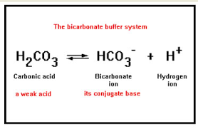

* When some strong acid is added to a buffer, the equilibrium is shifted to the left, and the hydrogen ion concentration increases by less than expected for the amount of strong acid added.
* Buffer solutions are necessary in biology for keeping the correct pH for proteins to work.
* Buffers can be prepared in multiple ways by creating a solution of an acid and its conjugate base.

When some strong acid (more H+) is added to an equilibrium mixture of the weak acid and its conjugate base, the equilibrium is shifted to the left, in accordance with Le Chatelier’s principle. This causes the hydrogen ion (H+) concentration to increase by less than the amount expected for the quantity of strong acid added. Similarly, if a strong base is added to the mixture, the hydrogen ion concentration decreases by less than the amount expected for the quantity of base added. This is because the reaction shifts to the right to accommodate for the loss of H+ in the reaction with the base.

**Methods of preparing buffers**

There are a couple of ways to prepare a buffer solution of a specific pH. In the first method, prepare a solution with an acid and its conjugate base by dissolving the acid form of the buffer in about 60% of the volume of water required to obtain the final solution volume. Then, measure the pH of the solution using a pH probe. The pH can be adjusted up to the desired value using a strong base like NaOH. If the buffer is made with a base and its conjugate acid, the pH can be adjusted using a strong acid like HCl. Once the pH is correct, dilute the solution to the final desired volume.

Alternatively, you can prepare solutions of both the acid form and base form of the solution. Both solutions must contain the same buffer concentration as the concentration of the buffer in the final solution. To get the final buffer, add one solution to the other while monitoring the pH.

In a third method, you can determine the exact amount of acid and conjugate base needed to make a buffer of a certain pH, using the Henderson-Hasselbach equation:

pH=pKa +log ([A−]/[HA])

where pH is the concentration of [H+], pKa is the acid dissociation constant, and [{A}-] and [{HA}] are concentrations of the conjugate base and starting acid.

